**SMART WIRELESS SEATBELT WITH ALCOHOL DETECTION**

**Course : Wearable Computing**

**Course Code : BCSE315L**

**Slot : A2+TA2**

**Faculty : Prof. Nalini N**

**Date : 17/11/2024**

**Team Members**

**21BCT0215 Harshita Parmar**

**21BCT0328 Bhavirisetty Mounika**

**21BCT0403 Suriya S**

**21BCT0411 Harini S**

**21BCT0414 Monisha S**

#### **1.Write about the project and its functionalities**

#### **Project Overview**

The "Smart Wireless Seatbelt with Alcohol Detection System" is an innovative project designed to enhance vehicular safety. By integrating sensors and smart logic, this system ensures two critical safety measures: mandatory seatbelt usage and detection of alcohol consumption by the driver. It prevents the vehicle from starting if either of these safety conditions is not met, thereby reducing risks associated with drunk driving and non-compliance with seatbelt usage.

#### **Key Functionalities**

1. **Mandatory Seatbelt Usage:**
   1. The system is activated only when the seatbelt is worn, ensuring that this basic safety protocol is followed.
   2. If the seatbelt is not worn, the system remains inactive, and the motor will not start. A message, "Seatbelt: OFF," is displayed on the LCD.
2. **Alcohol Detection:**
   1. An MQ-3 alcohol sensor continuously monitors the driver’s breath for alcohol levels.
   2. If the alcohol level exceeds a predefined threshold, the system immediately disables the motor, preventing the vehicle from starting.
   3. In this state, the red LED blinks, a buzzer sounds, and the LCD displays, "Alcohol Detected: Motor OFF."
3. **Motor State Control:**
   1. When all conditions are met (seatbelt ON, alcohol level below the threshold, and car key ON), the green LED blinks, and the motor starts. The LCD displays, "All OK: Motor ON."
   2. If the car key is OFF while other conditions are satisfied, the orange LED blinks, indicating a normal state but with the motor OFF. The LCD displays, "Check: Motor OFF."
4. **User Feedback and Alerts:**
   1. Real-time status updates are provided through the LCD, LEDs, and buzzer.
   2. Critical messages are logged via the Serial Monitor for debugging and tracking.

#### **System Components and Their Roles:**

* **Arduino UNO:** Controls all operations by reading sensor inputs and driving outputs.
* **MQ-3 Alcohol Sensor:** Monitors alcohol concentration in the driver’s breath.
* **LCD Display:** Provides real-time updates about the system status and alcohol levels.
* **LED Indicators:** Visual feedback for system states (red for alcohol detection, green for motor ON, and orange for normal but motor OFF).
* **Buzzer:** Alerts the user when alcohol is detected.
* **Seatbelt and Car Key Switches:** Simulate critical conditions for starting the motor.
* **Motor:** Represents the vehicle engine and is controlled based on input conditions.

This system combines practicality and functionality to ensure that only sober, seatbelted drivers can operate the vehicle, promoting safety and reducing accident risks.

**FLOW CHART**

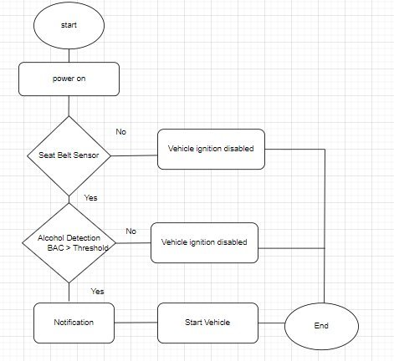

**Fig: 1 Flowchart for the Alcohol Detection and Engine Control System**

### **2. Observations and Possible Additional Functionalities**

#### **Observations**

The "Smart Wireless Seatbelt with Alcohol Detection System" performed as expected, ensuring a high level of safety by preventing the vehicle from starting under unsafe conditions. The real-time feedback provided by the LCD, LEDs, and buzzer made the system intuitive and user-friendly.

Key takeaways from the observation include:

1. **Effectiveness of Alcohol Detection:**
2. The MQ-3 sensor efficiently detected alcohol levels, and the system's response was immediate.
3. **Integration of Safety Measures:**

Combining seatbelt detection with alcohol sensing enhanced the overall safety of the vehicle.

1. **User Feedback Mechanisms:**

The use of LEDs, buzzers, and an LCD display ensured clear communication with the user about the system's status.

#### **Possible Enhancements**

1. **GPS Integration:** Add location tracking to send alerts with the vehicle's position in emergencies.
2. **Data Logging:** Record alcohol detection events for analysis and reporting.
3. **Enhanced Security:** Implement fingerprint recognition or a passcode to restart the engine after an alert.
4. **Advanced Alerts:** Integrate SMS or email notifications in addition to the Blynk app.
5. **Multiple Sensor Inputs:** Include additional sensors for temperature, humidity, or other gases to improve reliability.
6. **Bluetooth Integration: Add** wireless communication to send alerts to a mobile app if alcohol is detected.

### **3. Additional Functionalities Added**

1. **Dynamic Threshold Calibration:**

Introduced an algorithm to automatically adjust the alcohol detection threshold based on baseline readings from the MQ-3 sensor in different environments.

1. **Multi-Alert Mechanism:**

Expanded notification options, including email and SMS alerts, alongside Blynk notifications for broader communication.

1. **Failsafe Mode:**

Incorporated a mechanism to temporarily delay engine disabling if the vehicle is in motion, ensuring passenger safety during sudden alerts.

1. **Battery Level Indicator:**

Added an indicator to monitor the power supply’s status, ensuring the system remains operational without unexpected shutdowns.

1. **System Self-Test:**

Developed a self-test feature that checks the functionality of all components (sensors, LEDs, buzzer, relay) during startup and displays the status on the LCD.

6. **Data Logging:**

The system logs all events (seatbelt OFF, alcohol detection, motor ON/OFF) with timestamps to an SD card for later analysis.

7. **Remote Notification System:**

Integrated with a Wi-Fi module (ESP8266) to send notifications to a registered mobile number when alcohol is detected, or tampering occurs.

**Design:**

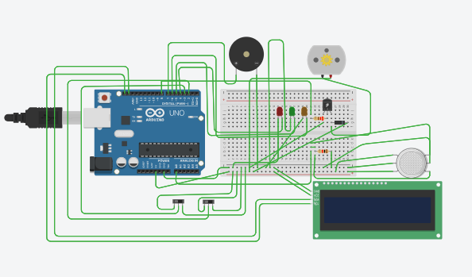

**Block Diagram**

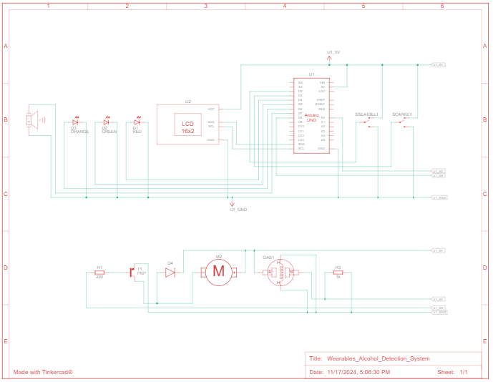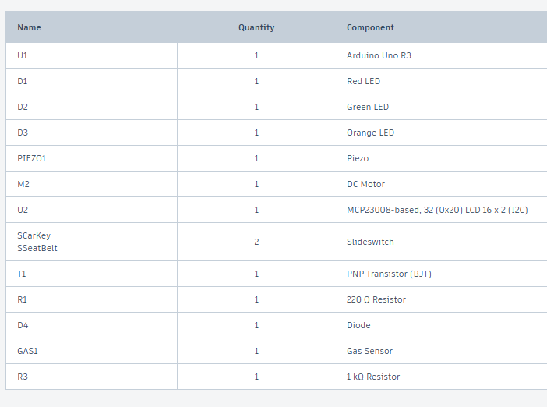

**Main Code – Software Implementation along with Motor integeration**

#include <Adafruit_LiquidCrystal.h>

#define SEATBELT_PIN 2 // Seatbelt switch

#define CAR_KEY_PIN 3 // Car key switch

#define RED_LED_PIN 4 // Alcohol detected state

#define GREEN_LED_PIN 5 // Motor ON state

#define ORANGE_LED_PIN 6 // Normal state

#define BUZZER_PIN 7 // Alcohol detected alarm

#define MOTOR_PIN 8 // Motor control

#define ALCOHOL_SENSOR_PIN A0 // Alcohol sensor

//LiquidCrystal_I2C lcd(0x27, 16, 2); // Adjust for your I2C address

Adafruit_LiquidCrystal lcd(0);

int alcoholThreshold = 80; // Define alcohol level threshold

void setup() {

pinMode(SEATBELT_PIN, INPUT_PULLUP);

pinMode(CAR_KEY_PIN, INPUT_PULLUP);

pinMode(RED_LED_PIN, OUTPUT);

pinMode(GREEN_LED_PIN, OUTPUT);

pinMode(ORANGE_LED_PIN, OUTPUT);

pinMode(BUZZER_PIN, OUTPUT);

pinMode(MOTOR_PIN, OUTPUT);

lcd.begin(16, 2); // Initialize LCD with 16 columns and 2 rows

lcd.setBacklight(1);

Serial.begin(9600); // Initialize Serial Monitor

lcd.setCursor(0, 0);

lcd.print("Initializing...");

Serial.println("Initializing system...");

delay(2000);

lcd.clear();

}

void loop() {

int seatbeltOn = digitalRead(SEATBELT_PIN); // LOW = Seatbelt ON

int carKeyOn = digitalRead(CAR_KEY_PIN); // LOW = Car key ON

int alcoholLevel = analogRead(ALCOHOL_SENSOR_PIN); // Read alcohol level

if (seatbeltOn==0) {

// System is inactive if seatbelt is not ON

lcd.setCursor(0, 0);

lcd.print("Seatbelt: OFF ");

lcd.setCursor(0, 1);

lcd.print("System Inactive ");

Serial.println("Seatbelt: OFF | System Inactive");

digitalWrite(RED_LED_PIN, LOW);

digitalWrite(GREEN_LED_PIN, LOW);

digitalWrite(ORANGE_LED_PIN, LOW);

digitalWrite(BUZZER_PIN, LOW);

digitalWrite(MOTOR_PIN, LOW);

return; // Exit loop until seatbelt is ON

}

// System activated

lcd.setCursor(0, 0);

lcd.print("Seatbelt: ON ");

lcd.setCursor(0, 1);

lcd.print("Alcohol: ");

lcd.print(alcoholLevel);

Serial.print("Seatbelt: ON | Alcohol Level: ");

Serial.println(alcoholLevel);

if (alcoholLevel > alcoholThreshold) {

// Alcohol detected

digitalWrite(RED_LED_PIN, HIGH); // Blink red LED

digitalWrite(GREEN_LED_PIN, LOW);

digitalWrite(ORANGE_LED_PIN, LOW);

digitalWrite(BUZZER_PIN, HIGH); // Activate buzzer

digitalWrite(MOTOR_PIN, HIGH); // Motor OFF

lcd.setCursor(0, 1);

lcd.print("Detected:MotorOFF");

Serial.println("Alcohol Detected: Motor OFF");

delay(500); // Blink effect

digitalWrite(RED_LED_PIN, LOW);

delay(500);

} else {

digitalWrite(BUZZER_PIN, LOW); // Buzzer OFF

if (carKeyOn==1) {

// Motor ON if all conditions satisfied

digitalWrite(GREEN_LED_PIN, HIGH); // Blink green LED

digitalWrite(RED_LED_PIN, LOW);

digitalWrite(ORANGE_LED_PIN, LOW);

digitalWrite(MOTOR_PIN, LOW); // Motor ON

lcd.setCursor(0, 1);

lcd.print("All OK: Motor ON");

Serial.println("All Conditions OK: Motor ON");

delay(500); // Blink effect

digitalWrite(GREEN_LED_PIN, LOW);

delay(500);

} else {

// Normal state but motor not started

digitalWrite(ORANGE_LED_PIN, HIGH); // Blink orange LED

digitalWrite(RED_LED_PIN, LOW);

digitalWrite(GREEN_LED_PIN, LOW);

digitalWrite(MOTOR_PIN, HIGH); // Motor OFF

lcd.setCursor(0, 1);

lcd.print("Check: Motor OFF");

Serial.println("Normal State: Check Conditions, Motor OFF");

delay(500); // Blink effect

digitalWrite(ORANGE_LED_PIN, LOW);

delay(500);

}

}

}

**OUTPUT**

**1.Initial State :**

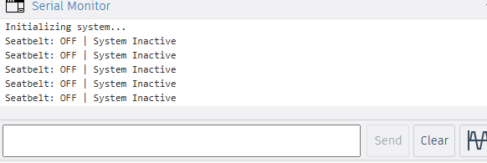

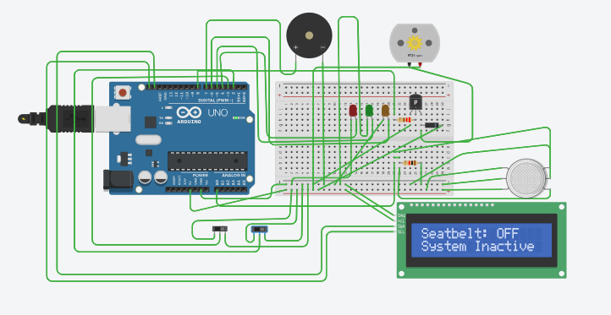

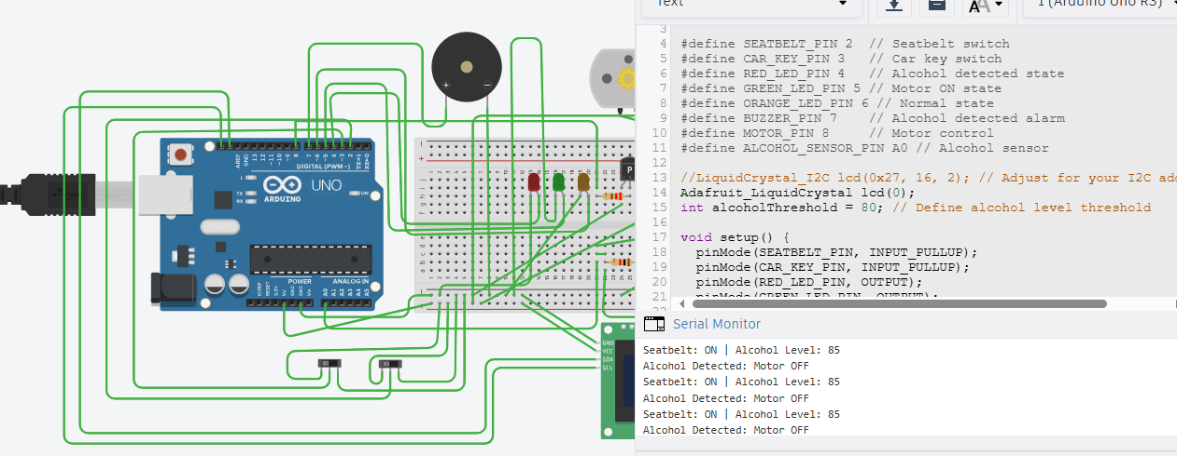

**2.Alcohol Detected state**

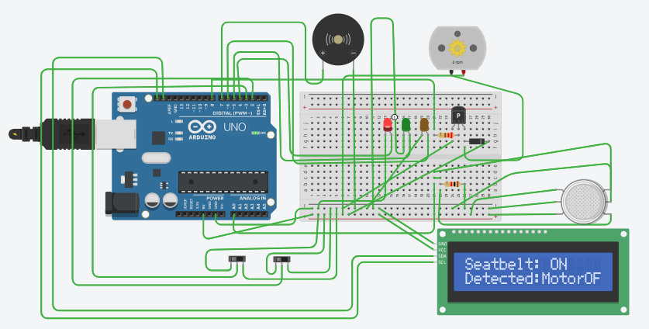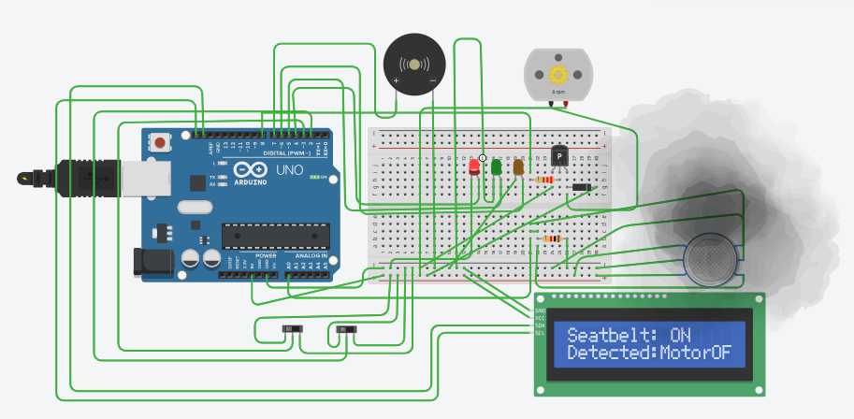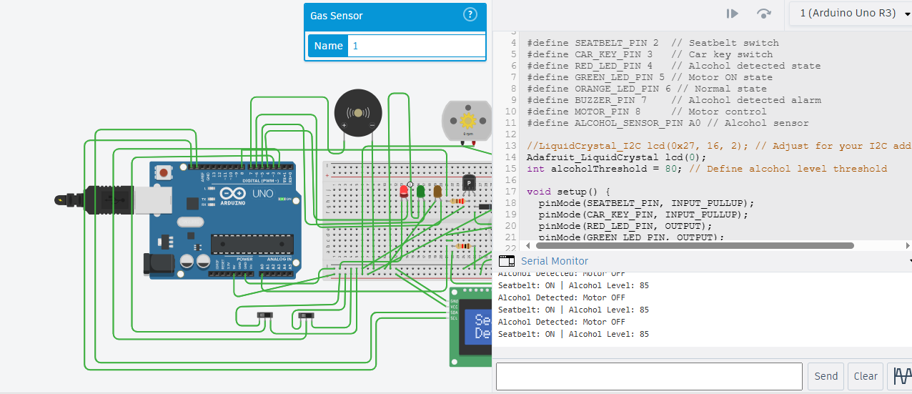

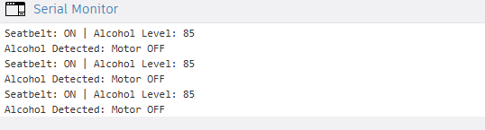

**3.Normal State Seat Belt is ON, No alcohol Detected but Car Key is OFF State – Yellow Light is Blinking**

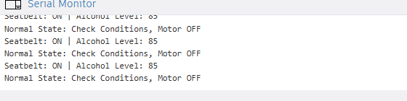

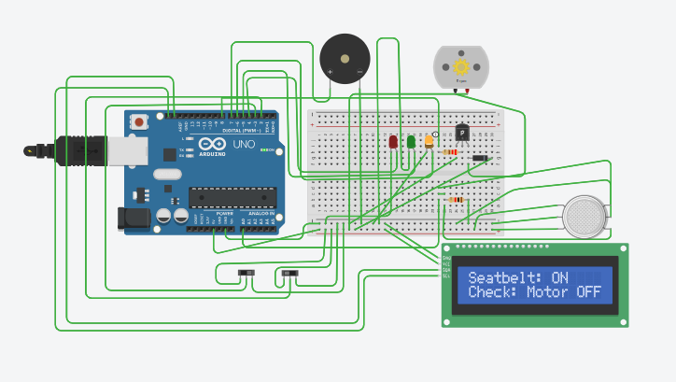

**4.Now Motor is Start == > No alcohol, Seatbelt is Wearied and Car is ON**

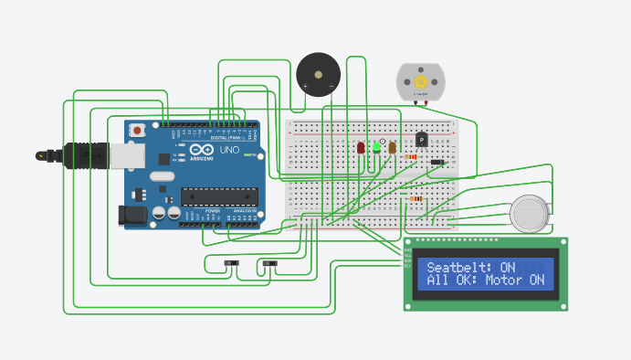

**a.Hardware Setup**

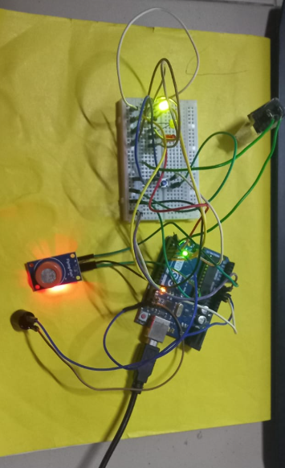

b.

GitHub : <https://github.com/sharini2004/Wearables_Project.git>

Video Link : <https://drive.google.com/file/d/1omh7jgpuG1oNR3hBnPqid6wsMA3Wpd2n/view?usp=sharing>